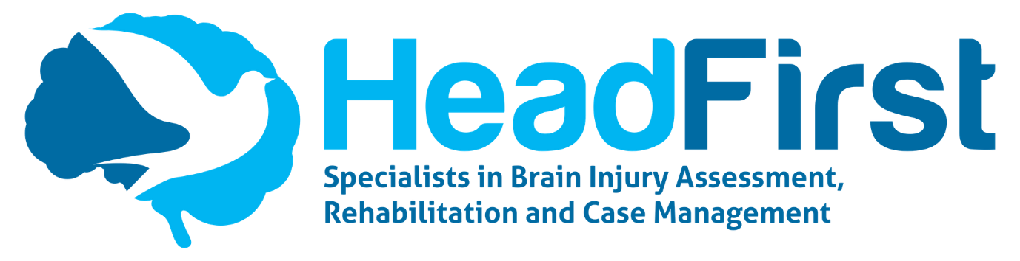

JOB DESCRIPTION – CASE MANAGEMENT ASSISTANT

Position: Case Management Assistant

Reporting To: HF Management Team / Case Management Team Coordinator

Job Summary: To work in liaison with the Case Management Team Coordinator in providing administrative and secretarial services to the Case Management service and the Head First Team, as required.

Key Working Relationships

A Maintain good working relationships with all members of the Head First team.

B Keep other team members informed of any information which is relevant to their team (e.g. medico-legal, wages, finance, HR, health and safety) using the agreed channels of communication.

C Liaison with external parties, e.g. therapists, Support Workers, solicitors etc.

- Key Tasks

To provide administrative and secretarial assistance to the Case Management service and Head First Team, as required.

Telephone

- Answer incoming telephone calls and direct as appropriate via the rota-based system, providing additional support to cover CMA team absence.

- When taking telephone messages, ensure that sufficient and accurate information (as well as date, time and number) is taken from the caller and passed on to the relevant person.

Screen unwanted messages, e.g. sales calls.

- If there is an urgent message, ensure that it reaches the person concerned.

- Adhere to the policy and procedures as set out in the Head First Staff Handbook.

- Ensure on-call system is allocated to the appropriate Case Manager and implemented via BT Cloud.

- EasyLog

- Setting up of ‘ideal’ client rota and amending where necessary.

- Checking alarms daily, following up with Support Workers to ascertain reason for discrepancies and actioning as required (sickness, holiday etc.)

- Running, downloading and uploading of weekly reports to facilitate Case Manager sign-off for payroll processing.

- Alchemer

- Create new or amend existing Support Worker Records via the Alchemer system in accordance with Case Manager input and guidance.

- Run reports as and when required

- Download Support Worker Records for disclosure to litigation teams as and when required

- Make notes of any malfunctioning records via the appropriate log.

2 Case Management-Specific Tasks

- Ensure that all documents are completed accurately and according to our standard administration procedures using standard layouts and checking spelling, grammar and content where appropriate.

- Ensure that any correspondence, reports etc. are uploaded and saved prior to sending.

- Send e-mails as required and according to our standard administration procedure.

- Enter receipt of incoming post on our intranet system and ensure it is forwarded to the relevant recipient.

- Undertake the formatting of reports, clinical documents, etc., ensuring latest copy is uploaded to the correct storage area

- Arrange the booking of meetings via Zoom and admitting the Case Manager at the relevant time.

- Attend and minute meetings as required; prepare accurate minutes and distribute in a timely manner

3 Client-Specific Tasks

- Source (where applicable) and arrange purchase of equipment or other goods in liaison with Case Manager, internal and external parties, adhering to Head First’s purchase order procedure.

- Research and book holidays for clients, their families and attending support staff. Liaise with Financial deputies where appropriate.

- Assist in all aspects of domestic organisation such as sourcing and booking cleaners, tradespersons, etc. to, as far as possible, facilitate clients’ independent living.

4 Maintain the filing systems for the Case Management service, in liaison with the Case Management Team Coordinator

- Ensure that Case Management filing is kept up to date following our standard filing procedures in liaison with other administrative staff, both hard copy or electronic filing.

- Create new files as requested and ensure that all relevant information including contact names and addresses, are placed ready in the file.

- Assist with maintaining the Case Management filing and archiving systems and keep up to date records of the same, in liaison with the Case Management Team Coordinator and other administrative staff.

- Keep all other computer files organised, downloaded and backed up.

- Be prepared to assist other teams as required.

5 Assist in the maintenance of the computerised clinical file note system.

- Maintain the computerised clinical file note system on a daily basis by means of inputting all billable notes.

- Download, format and prepare for disclosure case management file notes, by billable period, for relevant clients.

6 Be responsible for working with Case Managers to coordinate their diaries and appointments, arranging travel and accommodation as necessary.

- Work in liaison with Case Managers and the Finance Team to book travel tickets, accommodation and parking as requested.

- Attend regular (at least monthly) meetings with your designated Case Managers to discuss their requirements and action any requests resulting from these meetings.

7 Be responsible for working with Case Managers and Human Resources to coordinate Support Worker recruitment.

- Work in liaison with Case Managers and the Human Resources team to coordinate all administrative aspects of Support Worker recruitment, to include recruitment advertising, management of incoming CV’s and interview arrangements and liaison with the relevant person regarding recruitment funding.

- Facilitate the training of new Support Workers in the use of SharePoint and Alchemer, and any other applications they may need to access.

8 Provide cover for other members of the CMA team as required.

- Be prepared and flexible in your approach to help out during busy periods in other areas as required, e.g. holiday and sickness cover.

9 Adhere to the administration procedures as set out in the Head First Handbook.

- Ensure that our standard administration procedures are adhered to and help to establish new ones as necessary.

- Undertake any copying and scanning of documents, as required.

10 Maintain client confidentiality, security of the premises, and be responsible for the accuracy of own recordings.

- The last person on the daily phone rota is to ensure that the telephone system is diverted to the relevant Case Manager on call and the office shut down procedure has been carried out.

- At all times, respect the need for confidentiality when possessing knowledge of a private and personal nature about clients, their families and carers.

- Record any work undertaken according to our standard note-writing procedure, using the recognised format.

- Complete client contact forms, accurately recording time spent in direct contact for each case, as necessary.

- Keep an accurate record of hours worked using the systems provided and ensure that these are submitted to Head First payroll on a weekly basis.

- Keep an accurate record of any necessary mileage or expenses you have incurred for business and submit with receipts to Head First payroll on a weekly basis.

Other Information:

- All employees of Head First must commit to Equal Opportunities and Anti-Discriminatory Practice.
- Head First operates a Smoke-Free Policy and the post-holder is prohibited from smoking in any of Head First’s premises or other enclosed spaces.
- The post-holder is expected to familiarise themselves with and adhere to all relevant Head First Policies and Procedures.
- The post-holder must comply with Head First’s Health and Safety requirements.
- The post-holder must be eligible to live and work in the UK.

Signed ................................................................

Dated ................................................................

PERSON SPECIFICATION

Job title: Case Management Assistant

 | Essential | Desirable
Qualifications and Training | - Educated to GCSE Grade C and above, or equivalent  - Proficient in MS Office | - RSA III or equivalent touch typing/keyboard skills
Experience and Knowledge | - Secretarial/PA/Admin experience  - Computer literate with word processing experience  - Effective communication skills in person, in writing and on the telephone  - Experience of working for and within a team | - Knowledge or understanding of medical/clinical terms  - Previous experience of working in an environment of client confidentiality  - Previous experience of recording work activities as file notes
Skills and Abilities | - Ability to communicate effectively and professionally, by all methods, both internally and externally.  - Excellent organisational skills  - Ability to prioritise workload and meet deadlines  - Ability to remain calm in a busy environment whilst working under pressure  - Adaptability in the face of fast changing working procedures.  - Accurate touch typing/keyboard skills  - Undertake assistant duties including client queries, filing, scanning, data entry, database upkeep and file note entry  - Ability to multitask  - Ability to work on own initiative | - An understanding of data bases and their functionality
Personal qualities | - A team player.  - Demonstrates flexibility  - Understands their duty of care to all staff in relation to health and safety responsibilities  - Willingness to learn, with an open approach to new ways of working.  - Confidence in own abilities  - Pragmatic, common sense approach
Other requirements | - Eligible to live and work in the UK

